“QUICK” REFEREE SNAPSHOT

Name of referee: Relationship ___________

Name of applicant: _____________

School and position: Deputy Principal Target Rd School

Date Quick Referee Report needed: Tuesday 8 February 2022 by 5.00 pm.

This is a very quick referee report to give the Board a snapshot of what they might expect of a full report which is only asked of an applicant who has been shortlisted for interview. Please save this document to a hard drive, respond to the questions, save, then email as an attachment to Ngaire Jermaine – ngaire@keaeducation.nz.

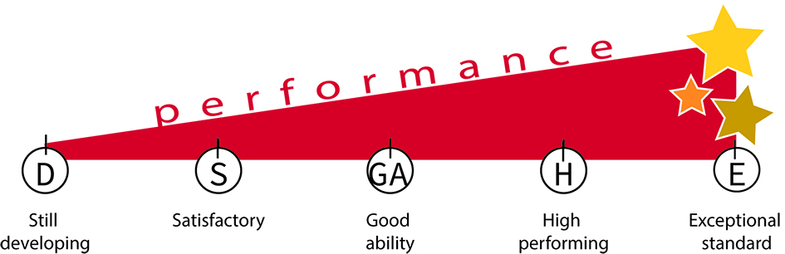
Please write no more than about ten words for each of these topics.
Rating scale is:
E - Exceptional standard
H - High performing
GA - Good ability
S - Satisfactory
D - Still developing

 | Topics | Comment | Rating
1 | Quality of relationships
2 | Quality of leadership
3 | Professional knowledge
4 | Professional skills
5 | Communication skills
6 | Personal and professional ethics.
7 | Knowledge or experience in tikanga.
8 | Reservations (if any)
10 | Your recommendation.
Final comments on suitability for our school including cultural appropriateness for our school

